Title*
Author Name Surname¹, Co-author Name Surname²
¹ Adress1
e-mail1
² Adress2
e-mail2
Abstract. 70-150 words.
Keywords: First keyword, second one.
- Introduction
First paragraph.
Second paragraph.
- Preparation of your paper
  - Structuring Your Paper

Affilation. The affiliated institutions are to be listed directly below the names of the authors. Multiple affiliations should be marked with superscript Arabic numbers, and they should each start on a new line as shown in this document. In addition to the name of your affiliation, we would ask you to give the town and the country in which it is situated. If you prefer to include the entire postal address, then please feel free to do so. E-mail addresses should start on a new line and should be grouped per affiliation.

Headings. Headings should be capitalized (i.e., nouns, verbs, and all other words except articles, prepositions, and conjunctions should be set with an initial capital) and should, with the exception of the title, be aligned to the left. Only the first two levels of section headings should be numbered, as shown in Table 1. The respective font sizes are also given in Table 1. Kindly refrain from using “0” when numbering your section headings.
Words joined by a hyphen are subject to a special rule. If the first word can stand alone, the second word should be capitalized. Here are some examples of headings: “Criteria to Disprove Context-Freeness of Collage Languages”, “On Correcting the Intrusion of Tracing Non-deterministic Programs by Software”, “A User-Friendly and Extendable Data Distribution System”, “Multi-flip Networks: Parallelizing GenSAT”, “Self-determinations of Man”.
Table 1. Font sizes of headings. Table captions should always be positioned above the tables.
Heading level | Example | Font size and style
Title (centered) | Lecture notes | 14 point, bold
1st level | - Introduction | 12 point, bold
2nd level | - Printing Area | 10 point, bold
3rd level | Run-in Heading in Bold. Text follows | 10 point, bold
4th level | Lowest Level Heading. Text follows | 10 point, italic

Lemmas, Propositions, and Theorems. The numbers accorded to lemmas, propositions, and theorems, etc. should appear in consecutive order, starting with Lemma 1. Please do not include section counters in the numbering like “Theorem 1.1”.
  - Figures and equations
Sample figure:
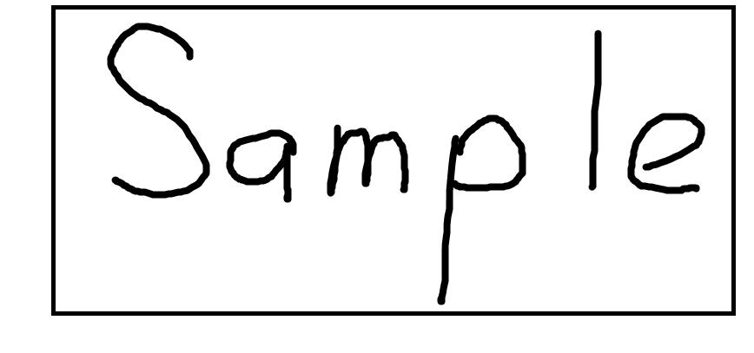
Fig. 1. Sample figure
Sample equation:
$x+y=z$ (1)
  - Program code
Program listings or program commands in the text are normally set in typewriter font:
program Inflation (Output)
{Assuming annual inflation rates of 7%, 8%, and
10%,... years};
const MaxYears = 10;
var Year: 0..MaxYears;
Factor1, Factor2, Factor3: Real;
begin
Year := 0;
Factor1 := 1.0; Factor2 := 1.0; Factor3 := 1.0;
WriteLn('Year 7% 8% 10%'); WriteLn;
repeat
Year := Year + 1;
Factor1 := Factor1 * 1.07;
Factor2 := Factor2 * 1.08;
Factor3 := Factor3 * 1.10;
WriteLn(Year:5,Factor1:7:3,Factor2:7:3,
Factor3:7:3)
until Year = MaxYears
end.
[Example of a computer program from Jensen K., Wirth N.: Pascal User Manual and Report. Springer, New York (1991)]
  - Bullets, dashes and numeric items
- Bullet1
- Bullet2
- Dash1
- Dash2
- Num1
- Num2
  - Citations and Bibliography
For citations in the text, please use square brackets and consecutive numbers. We would write [1,2,3,4,5] for consecutive numbers and [1], [3], [5] for non-consecutive numbers. The numbers in the bibliography section are without square brackets.
Please write all references using the Latin alphabet. If the title of the book you are referring to is in Russian, then please write in Russian at the end of the transcript or translation of the title.
The references section at the end of this paper shows a sample reference list with entries for journal articles [1], an LNCS chapter [2], a book [3], proceedings without editors [4] and [5], as well as a URL [6].
- Conclusions
Conclusions to work
References
- Smith, T.F., Waterman, M.S.: Identification of Common Molecular Subsequences. J. Mol. Biol. 147, 195–197 (1981)
- May, P., Ehrlich, H.C., Steinke, T.: ZIB Structure Prediction Pipeline: Composing a Complex Biological Workflow through Web Services. In: Nagel, W.E., Walter, W.V., Lehner, W. (eds.) Euro-Par 2006. LNCS, vol. 4128, pp. 1148–1158. Springer, Heidelberg (2006)
- Foster, I., Kesselman, C.: The Grid: Blueprint for a New Computing Infrastructure. Morgan Kaufmann, San Francisco (1999)
- Czajkowski, K., Fitzgerald, S., Foster, I., Kesselman, C.: Grid Information Services for Distributed Resource Sharing. In: 10th IEEE International Symposium on High Performance Distributed Computing, pp. 181–184. IEEE Press, New York (2001)
- Foster, I., Kesselman, C., Nick, J., Tuecke, S.: The Physiology of the Grid: an Open Grid Services Architecture for Distributed Systems Integration. Technical report, Global Grid Forum (2002)
- National Center for Biotechnology Information, http://www.ncbi.nlm.nih.gov

* This work was supported by the (acknowledgements)

